
Press contact: Nicole Myers 212-580-8029 press@worldmarchusa.net

Celebrity Billboards for Peace
The World March for Peace and Nonviolence Commemorates Hiroshima Day
August 6, 2009, Thursday
4:30 PM Mini-marches throughout Midtown Manhattan
6:30 PM Times Square Military Island – Declaration & Ceremony
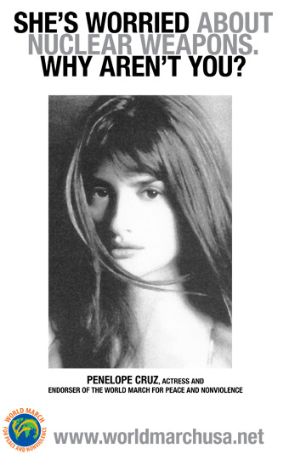
NEW YORK, August 2 — Sixty four years after the nuclear destruction of Hiroshima, organizers of The World March for Peace and Nonviolence (www.worldmarchusa.net) mark Hiroshima Day on August 6 by launching roving celebrity billboards throughout midtown Manhattan. The billboards will feature the faces of national presidents, Hollywood actors, musicians, Nobel Laureates and religious leaders who have endorsed the World March to demonstrate their deep concern about the unprecedented nuclear threat facing the world today.
The actions will begin in diverse points at 4:30 p.m. and will conclude with a gathering in Times Square (Military Island) at 6:30 p.m. and a declaration followed by a closing ceremony.
"It's important to mark this day not only to remember what happened but to prevent a future nuclear catastrophe,” says World March spokesperson Chris Wells. “The situation is far more dangerous and unstable than people realize. There is a growing call for abolition, in the UN, with Obama and Medvedev, and civil initiatives like the World March for Peace and Nonviolence and Global Zero. But we need to build up massive public support to make sure it happens."
The event is one of thousands planned globally by the World March to commemorate the dropping of the first atomic bomb and to draw attention to the threat of nuclear proliferation and its commitment to zero-tolerance for nuclear arms, a position echoed by many of the march’s prominent endorsers, including Miguel d’Escoto, The President of the United Nations General Assembly, and other world leaders.
In Japan, an international delegation from the World March will form part of the main ceremony to be held in Hiroshima on August 5th where the Nuclear Abolition Flame will be lit which will be carried around the globe during the World March for Peace and Nonviolence. http://www.abolitionflame.org/
ABOUT THE WORLD MARCH
Initiated by the organization World Without Wars, the World March for Peace and Nonviolence begins its historic journey October 2 in Wellington New Zealand before traveling through seven continents, 100 plus countries and 300 plus cities. It will arrive in New York City on November 30, 2009 and reach its final destination in Punta de Vacas, Argentina on January 2. 2010.
The primary goals of the World March include:
• nuclear disarmament at a global level
• immediate withdrawal of invading troops from occupied territories
• progressive and proportional reduction of conventional weapons
• signing of non-aggression treaties between countries
• renunciation by governments of the use of war as a means to resolve conflicts
The World March has been endorsed globally by thousands of individuals, pacifist and nonviolence groups, institutions and leading figures in science, culture and politics including former US President Jimmy Carter, Chilean President Michelle Bachelet, Yoko Ono, Penelope Cruz, Cindy Sheehan, South Africa's Desmond Tutu, Zubin Mehta, Viggo Mortensen, Abolition 2000 and Mayors for Peace, among others. For an extensive list of supporters, go to www.theworldmarch.org/.
For press inquiries and information, contact Nicole Myers at 212-580-8029 or press@worldmarchusa.net

###

worldmarchusa.net theworldmarch.org

